**CSC 1101 – Problem Solving and Programming Laboratory**

**Lab 17 – rory lange**

**25 points – Due March 30, 3:45pm**

**a)** Save this document with your name and the lab assignment number somewhere in the file name.

**b)** Type/paste your answers into the document.

**c)** Submit the following documents to the Canvas assignment link where you downloaded this document:

✓ This document.

✓ Your .cpp files renamed to .txt.

Submit the documents separately, not as one .zip file.

Write a C++ console application that counts the number of even and odd numbers stored in an array. Declare an integer array with 20 spots and place random numbers in the array. Then loop through the array and count the number even and odd numbers. To check if a number is even, you may use condition:

(arr[i] % 2 == 0)

You may use function **randomizeArray** in sample application **Arrays** on Canvas.

Your output should look like this:

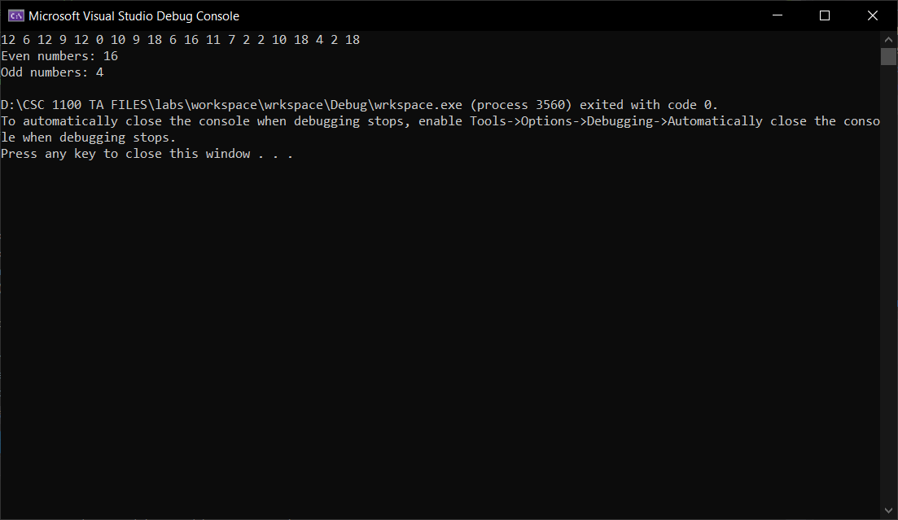

//==========================================================

//This is the header information

//

// Title: random array even or odd

// Course: CSC 1101

// Lab Number: lab 17

// Author: rory lange

// Date: 3/30/21

// Description: This assignment focuses on creating an array of

// size 20, populating the array with random numbers, counting the

// number of even and odd numbers in the array, and displaying

// the result

//==========================================================

#include <cstdlib> // For several general-purpose functions

#include <fstream> // For file handling

#include <iomanip> // For formatted output

#include <iostream> // For cin, cout, and system

#include <string> // For string data type

#include<cmath>//For math equations

#include<time.h>

using namespace std; // So "std::cout" may be abbreviated to "cout"

int main()

{

//Creates seed for random numbers

srand(time(NULL));

//declare variables

const int arrSize = 20;

int arr[arrSize];

int even = 0;

int odd = 0;

for (int i = 0; i < arrSize; i++) {

arr[i] = rand()%20;

if (arr[i] % 2 == 0)

even++;

else

odd++;

cout << arr[i] << " ";

}

cout << endl << "Even numbers: " << even << endl;

cout << "Odd numbers: " << odd << endl;

}

**If possible, format your code like this:**

**Font “Courier New”**

**Font size “9”**

**Bold**

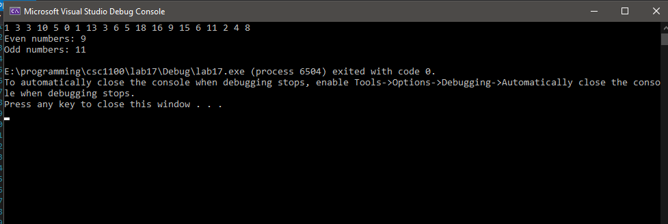

**\* Copying-and-pasting C++ code to a Word document**

**macOS**

1) From within the C++ program, press **command-A** and press **command-C**.

2) From within the Word document, press **command-V**.

**Windows**

1) From within the C++ program, press **CTRL-A** and press **CTRL-C**.

2) From within the Word document, press **CTRL-V**.

**\*\* Copying-and-pasting C++ console application output to a Word document**

**macOS**

1) From the C++ console, press **shift-command-4-space**.

2) From within the Word document, **command-V**.

**Windows**

1) From the C++ console, press **ALT-PrintScreen**.

2) From within the Word document, press **CTRL-V**.